**Group 8.**

|  |  |
| --- | --- |
| **Name** | **Registration number** |
| Samwel Ndayeza | T22-03-01399 |
| Walter Godliving | T22-03-08661 |
| Novert Kimaro | T22-03-01916 |

**Event planner application.**

For a very long time, people had trouble in finding the items needed so as to host a party or any celebration. The purpose of this application is to connect a customer in an emergency to a large number of dealers who offer renting services of a particular product.

**Main Objective**

The main objective of this application is to narrow the scope of searching when an individual is about to hold a party or ceremony and will obviously look need numerous items for that purpose.

**Database design.**

*Entity Relationship Diagram (ERD)*

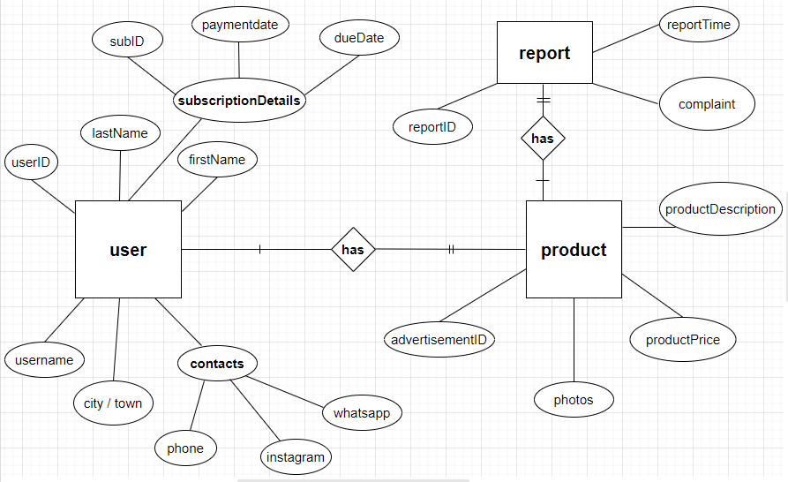

*Logical Schema.*

**Functional Requirements.**

Below is a list of functional requirements in every activity.

**Registration activity.**

|  |  |
| --- | --- |
| **Req. No.** | **Functional requirement.** |
| R1.1 | The user is required to enter his/her first name for identification. |
| R1.2 | A user is required to fill in his or her correct surname so as to narrow the scope of identification among other users having the same username. |
| R1.3 | A user is supposed to specify the correct location (City/ Town) where his or her premises. |
| R1.4 | A user is required to fill in his or her reachable phone number for easy communication with customers. |
| R1.5 | A link to the Instagram page of the dealer is required. This is so as to ensure availability incase the phone number is currently / no longer reachable. |
| R1.6 | A link to the WhatsApp chat page of the dealer is required. This is so as to ensure availability incase other means are currently / no longer reachable. |
| R1.7 | The user is supposed to select a username. This is not necessarily the name of the business but it should be suggested to be so. |

**Login activity**

|  |  |
| --- | --- |
| **Req. No.** | **Functional Requirement.** |
| R2.1 | A user is supposed to fill in the username which he or she chose upon account creation |
| R2.2 | The user is required to fill in a password which corresponds to the username entered for authentication purposes. |
| R2.3 | A quick access link to the sign up page is needed so as to redirect the user to that page incase he/she wishes to register a business into the system |

**Welcome activity.**

|  |  |
| --- | --- |
| **Req. No.** | **Functional requirement.** |
| R3.1 | The user should be informed about the purpose of the application. |
| R3.2 | A user is supposed to specify the location (City /Town ) where the expected party is to be held. |
| R3.3 | A quick access linkage is needed so as to redirect the user to a registration activity so that he can register his or her business into our system for advertisement. |
| R3.4 | A quick access linkage is needed so as to redirect the user to a login activity incase he has a business registered in our system. |

**Profile activity**

|  |  |
| --- | --- |
| **Req. No.** | **Functional requirement.** |
| R4.1 | A user is required to write a description of the product that he or she wants to advertise. |
| R4.2 | The user is required to write the price of the item to be advertised. |
| R4.3 | A user is required attach up to three photos of the product to be advertised. |
| R4.4 | A user should be able to view previous ads that he or she posted previously and the due date in which each of them ends. |

**Search Activity.**

|  |  |
| --- | --- |
| **Req. No**. | **Functional requirement.** |
| R5.1 | A user is required to enter the item he or she is looking for. A list of items will be returned in and the corresponding dealers offering them for rent. |
| R5.2 | Incase a user searches and gets unethical results , he should be able to report that particular advertisement to the administrators. |

**Administrators Activity**

|  |  |
| --- | --- |
| **Req. No.** | **Functional requirement.** |
| R6.1 | The administrator is required to oversee all advertising services the system offers. Incase any of the ads posted violates the cyber crimes act of 2015 of the government of Tanzania. The administrator is given the privilege to delete that particular advertisement. |